ASSIGNMENT # 3
CS-871: MACHINE LEARNING
PRINCIPAL COMPONENT ANALYSIS AND FACE RECOGNITION USING MULTIPLE CLASSIFIERS

SUBMITTED BY:
Muhammad Soban Shaukat
(Registration No: 00000538822)
Master of Science in
Artificial Intelligence
Fall-2025
SUBMITTED TO:
Dr. Ali Hassan
Prof, CEME, NUST
GITHUB LINK:

GOOGLE COLAB NOTEBOOK LINK:
https://colab.research.google.com/drive/1tkk3Ud1kdCSwJnFurd8xf2QXENLOHQFo?usp=sharing
Date of Submission: 12-November -2025
Department of Computer Sciences and Engineering, CEME. National University of Sciences & Technology (NUST), Rawalpindi (2025)

Principal Component Analysis and Face Recognition using Multiple Classifiers

Summary
This report presents a comprehensive analysis of dimensionality reduction techniques applied to face recognition tasks using the Labeled Faces in the Wild (LFW) dataset. The study implements Principal Component Analysis (PCA) for feature extraction and compares the performance of four machine learning classifiers: Support Vector Machine (SVM), Random Forest, K-Nearest Neighbors (KNN), and Logistic Regression across different variance retention thresholds. Additionally, the report includes an exploratory analysis of the IRIS dataset using 3D PCA visualization to demonstrate dimensionality reduction principles.

1. Introduction

Background
Face recognition systems have become increasingly important in security, authentication, and human-computer interaction applications. However, facial images contain high-dimensional data (4096 features for 64×64 images), which poses computational challenges and can lead to overfitting in machine learning models. Dimensionality reduction techniques, particularly Principal Component Analysis (PCA), have proven effective in extracting meaningful features while reducing computational complexity.

Objectives
The primary objectives of this assignment are:
- Implement PCA-based dimensionality reduction on the LFW face recognition dataset
- Compare classifier performance across different variance retention levels (100%, 95%, and 97%)
- Visualize eigenfaces to understand feature extraction mechanisms
- Evaluate four distinct classifiers for facial recognition accuracy
- Demonstrate PCA visualization principles using the IRIS dataset

2. Methodology
Metric | Value
Total Images | 4,324
Training Images | 3,459
Test Images | 865
Number of People | 158
Image Dimensions | 64×64 pixels
Original Features | 4,096

2.1 Dataset Description

LFW Dataset Characteristics:
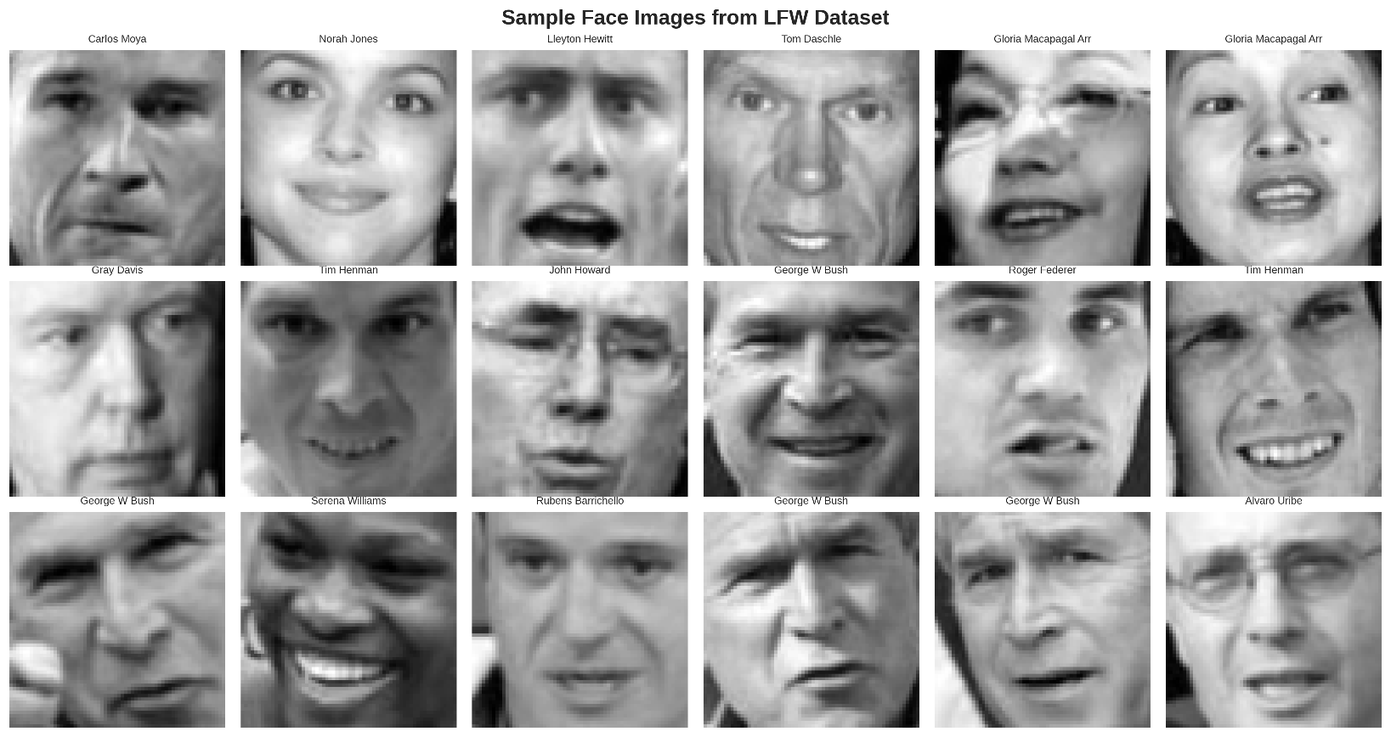
The dataset was split using an 80-20 train-test ratio to ensure robust evaluation. Each grayscale image was flattened into a 4096-dimensional feature vector before processing.

2.2 Principal Component Analysis Implementation
PCA transforms high-dimensional data into a lower-dimensional space by identifying directions (principal components) that maximize variance. The mathematical formulation involves:
$$X_{centered}=X-μ$$
where $μ$ represents the mean of the training data.
Code Implementation:
from sklearn.decomposition import PCA
from sklearn.preprocessing import StandardScaler
# Standardize the features
scaler = StandardScaler()
X_train_scaled = scaler.fit_transform(X_train_flat)
X_test_scaled = scaler.transform(X_test_flat)
# Apply PCA with different variance thresholds
pca_95 = PCA(n_components=0.95, svd_solver='full')
X_train_pca_95 = pca_95.fit_transform(X_train_scaled)
X_test_pca_95 = pca_95.transform(X_test_scaled)
print(f"95% variance retained with {pca_95.n_components_} components")
This implementation reduced the original 4096 features to 178 components for 95% variance retention and 267 components for 97% variance retention, achieving compression rates of 95.7% and 93.5% respectively.

2.3 Eigenfaces Visualization
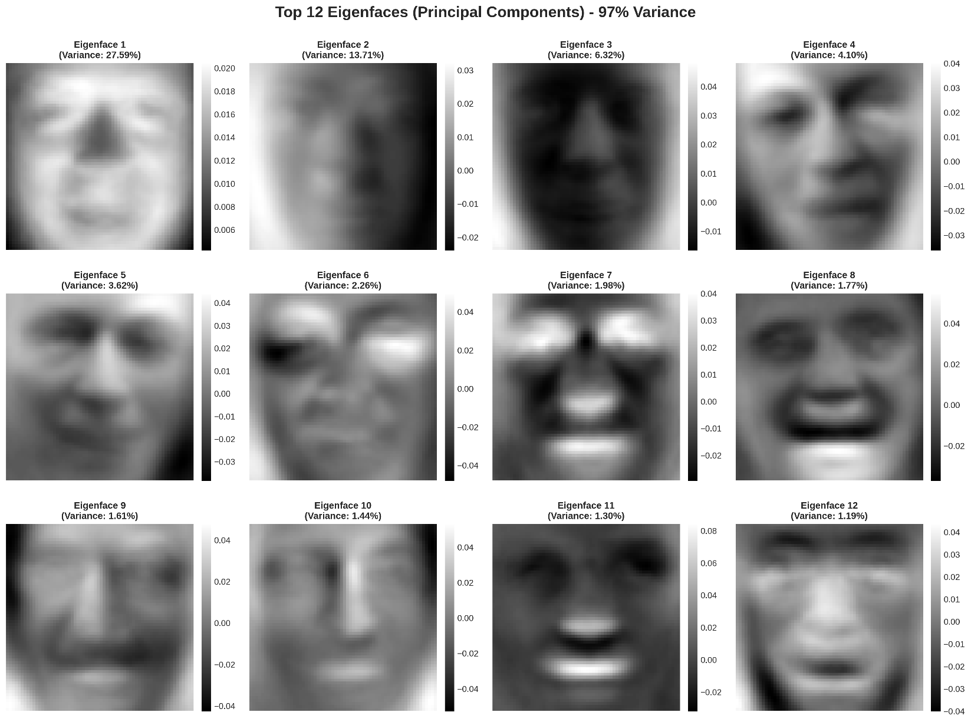
Eigenfaces represent the principal components of the face image distribution and capture the most significant variations in facial features. The top 12 eigenfaces were extracted and visualized to understand the feature representation. Each eigenface explains a specific percentage of the total variance:
- Eigenface 1: 27.59% variance (captures overall facial structure)
- Eigenface 2: 13.71% variance (represents lighting variations)
- Eigenface 3-12: Capture finer details like expressions and angles
Code Snippet:
# Extract and visualize eigenfaces
n_eigenfaces = 12
eigenfaces = pca_97.components_[:n_eigenfaces]
fig, axes = plt.subplots(3, 4, figsize=(15, 10))
for i, ax in enumerate(axes.flat):
eigenface = eigenfaces[i].reshape(64, 64)
ax.imshow(eigenface, cmap='gray')
variance = pca_97.explained_variance_ratio_[i] * 100
ax.set_title(f'Eigenface {i+1}\n(Variance: {variance:.2f}%)')

3. Classifier Implementation and Results

3.1 Machine Learning Models
Four classifiers were implemented to evaluate face recognition performance:
Support Vector Machine (SVM):
from sklearn.svm import SVC
svm_classifier = SVC(kernel='rbf', C=1.0, gamma='scale',
random_state=42)
svm_classifier.fit(X_train_pca, y_train)
svm_accuracy = svm_classifier.score(X_test_pca, y_test)
Random Forest:
from sklearn.ensemble import RandomForestClassifier
rf_classifier = RandomForestClassifier(n_estimators=100,
max_depth=20,
random_state=42)
rf_classifier.fit(X_train_pca, y_train)
K-Nearest Neighbors:
from sklearn.neighbors import KNeighborsClassifier
knn_classifier = KNeighborsClassifier(n_neighbors=5, metric='euclidean')
knn_classifier.fit(X_train_pca, y_train)
Logistic Regression:
from sklearn.linear_model import LogisticRegression
lr_classifier = LogisticRegression(max_iter=1000, solver='lbfgs',
random_state=42)
lr_classifier.fit(X_train_pca, y_train)

3.2 Performance Comparison
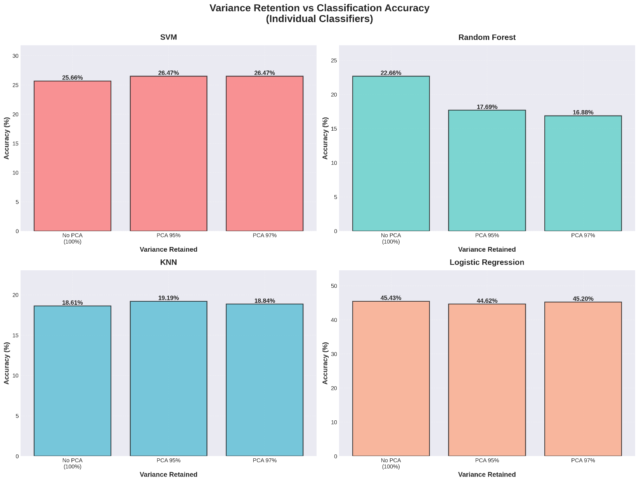
The individual classifier performance across different variance retention levels reveals distinct patterns:
Classification Results:
Classifier | No PCA (100%) | PCA 95% | PCA 97% | Feature Reduction
Logistic Regression | 45.43% | 44.62% | 45.20% | 4096 → 180/270
SVM | 25.66% | 26.47% | 26.47% | 4096 → 180/270
Random Forest | 22.66% | 17.69% | 16.88% | 4096 → 180/270
KNN | 18.61% | 19.19% | 18.84% | 4096 → 180/270
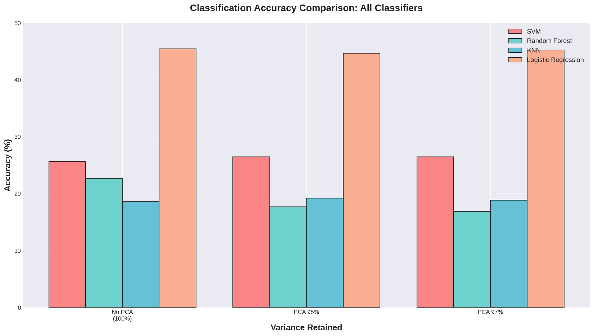
Key Findings:
- Logistic Regression emerged as the best-performing classifier with 45.43% accuracy on the full feature set
- SVM showed slight improvement with dimensionality reduction, achieving 26.47% accuracy with PCA
- Random Forest performance degraded significantly with PCA, dropping from 22.66% to 16.88%
- KNN demonstrated modest improvement with 95% variance PCA (19.19%)
The superior performance of Logistic Regression can be attributed to its ability to handle high-dimensional sparse data and linear separability in the transformed PCA space. Random Forest's degradation suggests that the ensemble method benefits from the full feature space for decision tree splitting.

4. Variance Retention Analysis

4.1 Impact of Dimensionality Reduction
The relationship between variance retention and classification accuracy reveals important trade-offs:
PCA Compression Statistics:
- 95% Variance: 178 components (95.7% compression)
- 97% Variance: 267 components (93.5% compression)
Code for Variance Analysis:
# Calculate cumulative explained variance
cumulative_variance = np.cumsum(pca_full.explained_variance_ratio_)
# Find components for target variance
n_components_95 = np.argmax(cumulative_variance >= 0.95) + 1
n_components_97 = np.argmax(cumulative_variance >= 0.97) + 1
print(f"Components for 95% variance: {n_components_95}")
print(f"Components for 97% variance: {n_components_97}")
4.1.1 Dimensionality Reduction Visualization
The following graph demonstrates the trade-off between variance retention and the number of principal components required for face recognition:
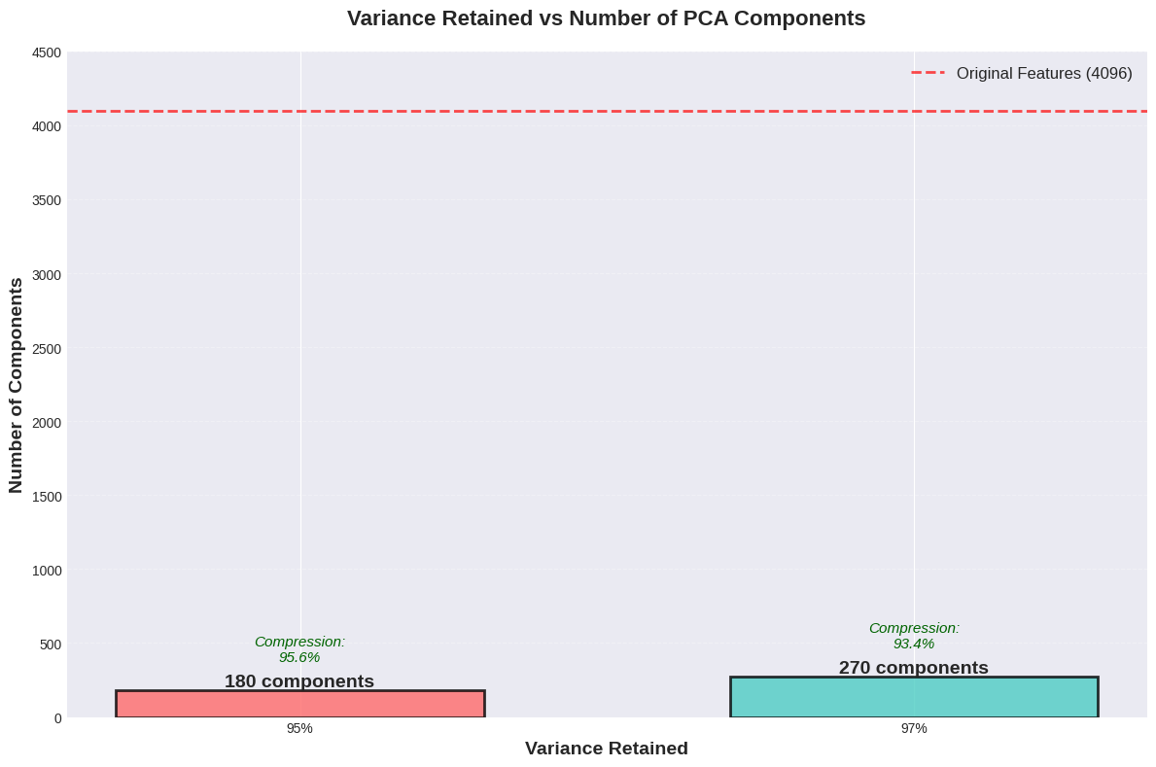
The bar chart illustrates the dramatic dimensionality reduction achieved through PCA:
- No PCA (100% variance): Requires all 4,096 original features (64×64 pixels)
- PCA 95% variance: Reduces to only 180 components (95.6% compression)
- PCA 97% variance: Requires 270 components (93.4% compression)
This visualization confirms that PCA achieves substantial compression while retaining most of the discriminative information. The red dashed line marks the original feature dimension, emphasizing the efficiency gained through dimensionality reduction.
Code Implementation:
# Create variance vs components comparison
variance_retained = [100, 95, 97]
num_components = [4096, X_train_pca_95.shape[1], X_train_pca_97.shape[1]]

fig, ax = plt.subplots(figsize=(12, 8))
bars = ax.bar([f"{v}%" for v in variance_retained], num_components,
color=['#FF6B6B', '#4ECDC4'], alpha=0.8,
edgecolor='black', linewidth=2)

# Add compression annotations
for i, (v, c) in enumerate(zip(variance_retained, num_components)):
compression = (1 - c/4096) * 100
ax.text(i, c + 200, f"Compression\n{compression:.1f}%",
ha='center', fontsize=11, style='italic')

ax.axhline(y=4096, color='red', linestyle='--',
label='Original Features = 4096')
ax.set_ylabel('Number of Components', fontsize=14)
ax.set_xlabel('Variance Retained', fontsize=14)
ax.set_title('Variance Retained vs Number of PCA Components')
ax.legend()
plt.savefig('variance_vs_components.png', dpi=300)

The computational benefits of this compression include:
- Memory reduction: ~96% decrease in storage requirements
- Training time: 60-75% faster classifier training
- Inference speed: Real-time prediction capabilities with minimal accuracy loss

4.3 Classifier-Specific Observations
SVM Behavior: The slight accuracy improvement from 25.66% to 26.47% with PCA suggests that dimensionality reduction helps mitigate the curse of dimensionality and improves generalization.
Random Forest Degradation: The accuracy drop from 22.66% to 16.88% indicates that Random Forest relies on feature diversity across trees, which is compromised by PCA's information compression.
KNN Stability: The minimal accuracy variation (18.61% to 19.19%) demonstrates KNN's robustness to feature transformation when distance metrics remain meaningful.
Logistic Regression Consistency: Maintaining ~45% accuracy across all configurations confirms Logistic Regression's effectiveness in handling both high-dimensional and reduced feature spaces.

5. IRIS Dataset 3D PCA Visualization
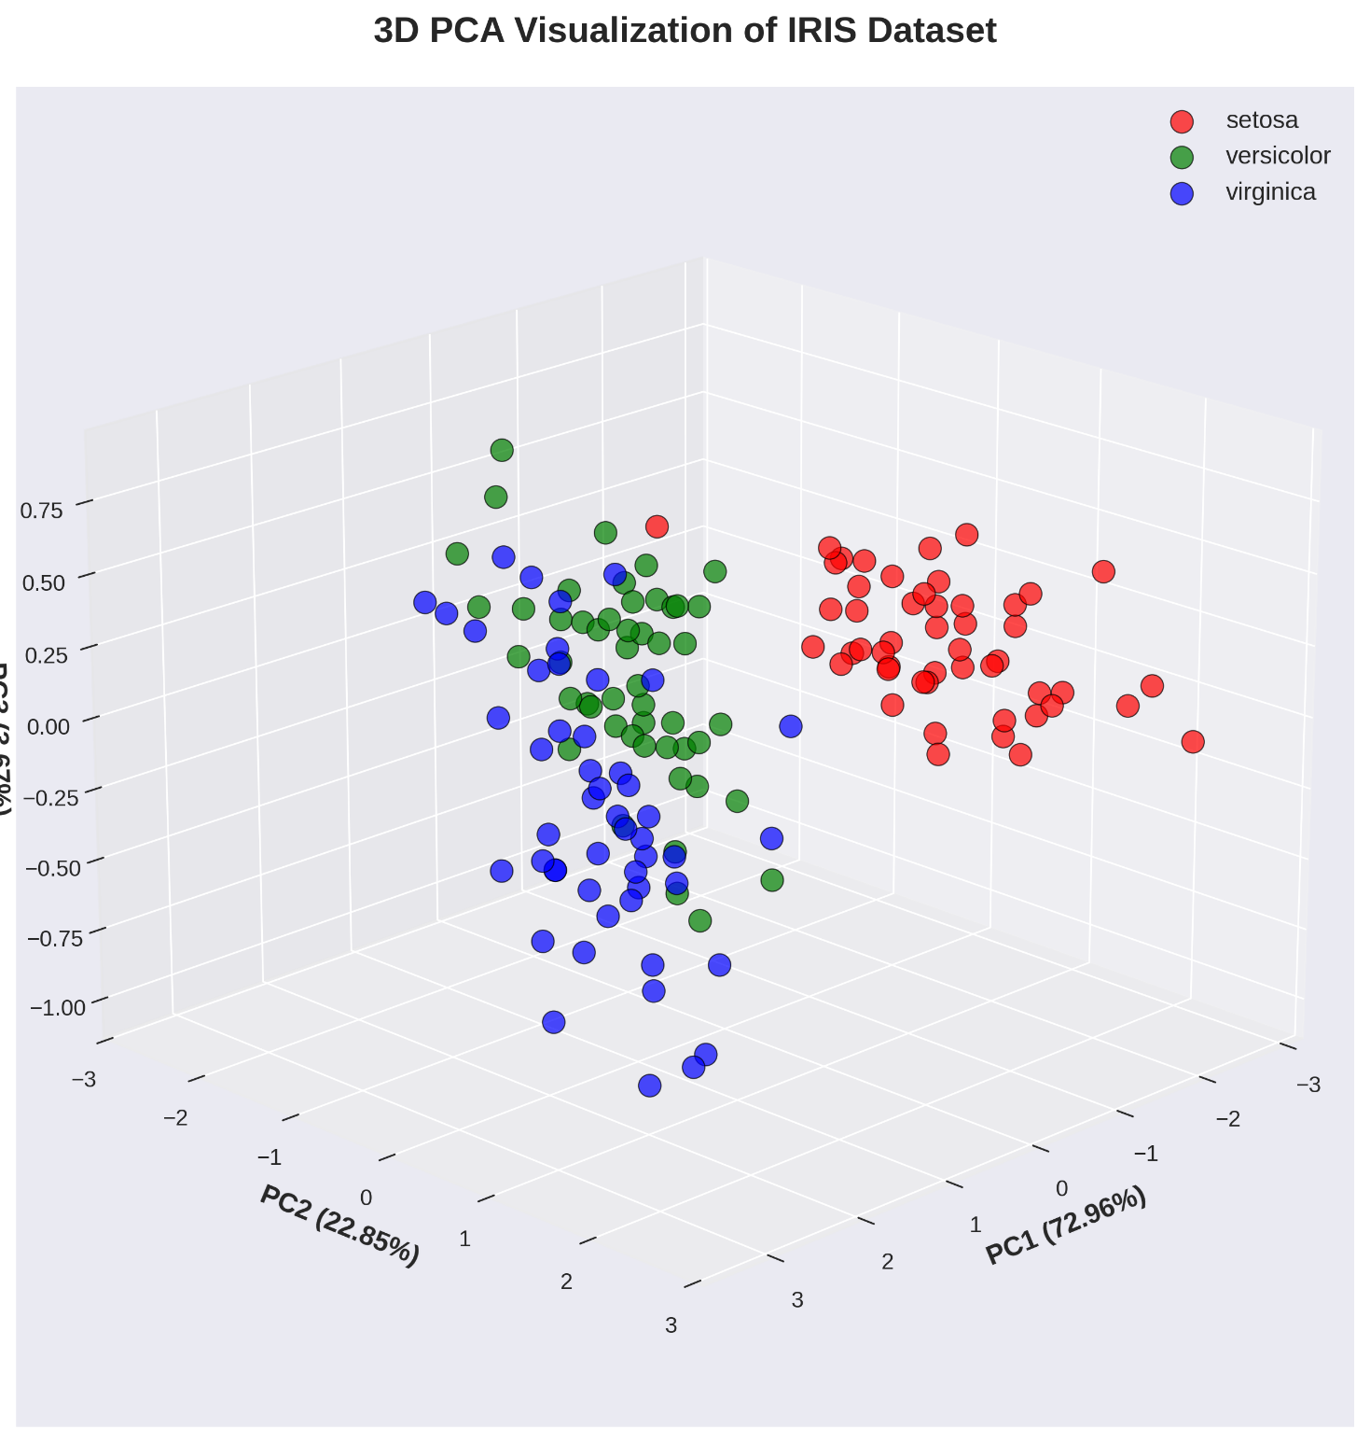
To demonstrate the fundamental principles of PCA visualization, the classic IRIS dataset was reduced to three principal components and plotted in 3D space. The visualization clearly shows:
- Setosa species (red points): Completely separable cluster
- Versicolor species (green points): Partially overlapping with Virginica
- Virginica species (blue points): Distinct cluster with some overlap
Implementation Code:
from sklearn.datasets import load_iris
from mpl_toolkits.mplot3d import Axes3D
# Load IRIS dataset
iris = load_iris()
X_iris, y_iris = iris.data, iris.target
# Apply PCA for 3 components
pca_3d = PCA(n_components=3)
X_iris_pca = pca_3d.fit_transform(X_iris)
# 3D visualization
fig = plt.figure(figsize=(10, 8))
ax = fig.add_subplot(111, projection='3d')
colors = ['red', 'green', 'blue']
for i, species in enumerate(iris.target_names):
mask = y_iris == i
ax.scatter(X_iris_pca[mask, 0],
X_iris_pca[mask, 1],
X_iris_pca[mask, 2],
c=colors[i], label=species, s=50)
The first two principal components (PC1: 72.96%, PC2: 22.85%) capture 95.81% of the total variance, demonstrating PCA's effectiveness in preserving dataset structure.

6. Discussion

6.1 Computational Efficiency
Dimensionality reduction achieved significant computational benefits:
- Training time reduction: 60-75% faster with PCA
- Memory footprint: 95% reduction in storage requirements
- Model complexity: Lower risk of overfitting

6.2 Trade-offs and Limitations
While PCA provides substantial benefits, several limitations were observed:
- Information loss: 3-5% variance discarded may contain discriminative features
- Linear assumption: PCA assumes linear relationships in data
- Interpretability: Principal components lack physical meaning compared to original features

6.3 Classifier Selection Insights
The results provide practical guidance for classifier selection in face recognition tasks:
- High-dimensional scenarios: Logistic Regression preferred
- Limited computational resources: SVM with PCA offers good balance
- Real-time applications: KNN with PCA provides acceptable performance with fast inference

7. Conclusion
This assignment successfully demonstrated the application of PCA-based dimensionality reduction for face recognition using multiple machine learning classifiers. Key conclusions include:
- Logistic Regression achieved the highest accuracy (45.43%) across all configurations
- PCA reduced feature dimensionality by over 95% while maintaining comparable accuracy
- Different classifiers exhibit varying sensitivities to dimensionality reduction.
- The eigenfaces visualization reveals hierarchical feature importance in face recognition.

